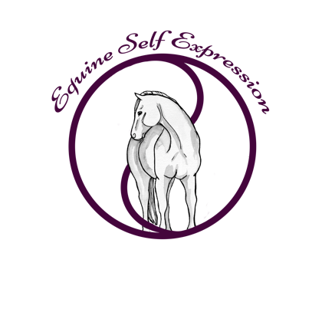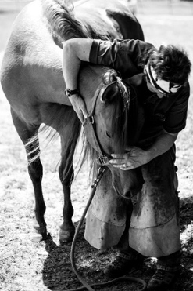
Equine Self Expression & Ida Hammer
Team up to present
“Unveiling the Hoof and Neck Connection”
Understanding the Relationship Between Hoof Balance and Functional Movement in Relationship to the Neck
$150.00 per participant
For more information on how to sign up for this clinic, please go to www.mackinawdells2.com
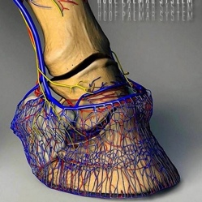
“Movement, balance, weight distribution, straightness”! Are we speaking of the function of the hoof? Or could it be the neck, often referred to as the pendulum or rudder of the horse, the most flexible part of the horse’s spine that allows him to carry weight and alter his center of gravity. Is it possible that this intricate dance of a horse’s functional posture is dependent upon the balance of both the hoof and the neck?

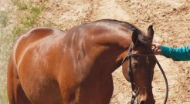
For the first time, Whole Horse Trimmer, Rehabilitation Specialist, Hoof Trim Educator and Consultant, Ida Hammer, will team up with Equine Self Expression’s Debbie Davies, to present a combination clinic to help students unveil the relationship between the neck and the feet.
Most of you will have heard the 18th century saying, “no foot, no horse”. There are many implications to this statement, but the most obvious awareness is that the entire weight of a horse’s body is loaded over 4 feet while he is standing, one while he is galloping and a variation there of through the transitions to other gaits. The foot is the foundation to all that your horse is and all that he does. Not only does the foot impact a horse physically, but mentally and emotionally as well.
The neck of the horse is more than just the pendulum or rudder as suggested above. A horse’s neck is responsible for the entire balance of the body, with conformational and anatomical characteristics that influence the form and function of dynamic and static posture. The neck itself, and in relationship with the skull, the jaw and the hyoid apparatus, are responsible for longitudinal and lateral flexion as well as bend throughout the horse and localized rotation. There are over 10 superficial and deep muscles of the neck that are influenced by, and influence the hoof, the balance and trajectory of the hoof, as well as foot fall, placement and gait. Training and straightness have a direct relationship to correct neck function and health, and correct neck function is directly impacted by the balance of the hoof.
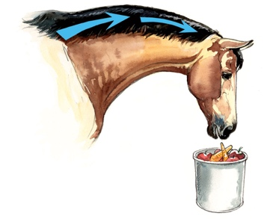
In this clinic, participants will have a unique opportunity to witness ‘before’ and ‘after’ functional, and compensatory patterns related to both hoof imbalance and neck dysfunction. Seeking self-carriage in a horse is not only about understanding the sequencing and function of the muscles in movement. It is also associated to the relationship between the muscles, particularly of the neck, as they either align or adapt to compensatory patterns relative to hoof imbalance, pain, contraction or restrictive trimming or shoeing forms.

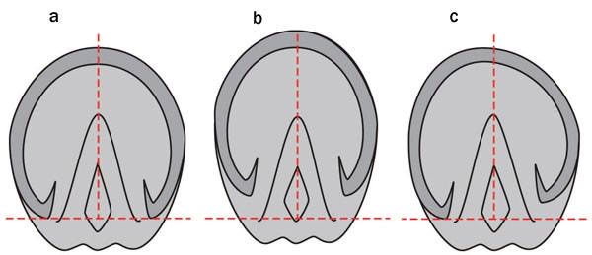
Students will leave this intense one-day clinic with a deeper understanding of the relationship between the hoof and neck balance, answering many questions as to the how and why of neck posture and foot fall, both under saddle and at liberty. So often, students experience frustration at the displacement of muscular balance in their horses’ neck, and irregularity in foot fall and stride in spite of supportive training methodologies. Bracing, ventro-flexion, lack of side bend, lateral flexion or longitudinal flexion, tightness in the jaw, to name a few of the so-called training frustrations that students experience. This clinic will illuminate some of the reasons that your horse maybe experiencing any of these imbalances, which also affect the neurologic function of his entire system, and prevent freedom of movement and transitions though the gaits.
Join us for an educational experience that will take you to the next level of learning and growing as a horseman and rider, allowing your horse to find the grace, relaxation and freedom of movement that he deserves to have, every stride, every ride.

SCHEDULE
- Movement and balance patterns of the horse related to the neck and hoof
- Gait analyses, functional neck release patterns and foot fall videos ‘before’
- Evaluating the hoof and its dynamic balance
- Evaluating the neck and its dynamic balance
- Observations of change in the neck through trimming and rebalancing
- Observations of change in the hoof through neck release exercises
- Gait analyses, functional neck release patterns and foot fall videos ‘after’
- Take home exercises for the student.

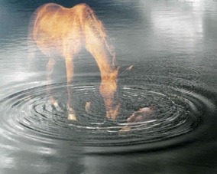
To host this clinic,
please contact Carissa Sorenson, at
Equineselfexpression1@gmail.com

Ida Hammer, at
Ida@mackinawdells2.com

Or Debbie Davies at
Equestrianeducation@juno.com

