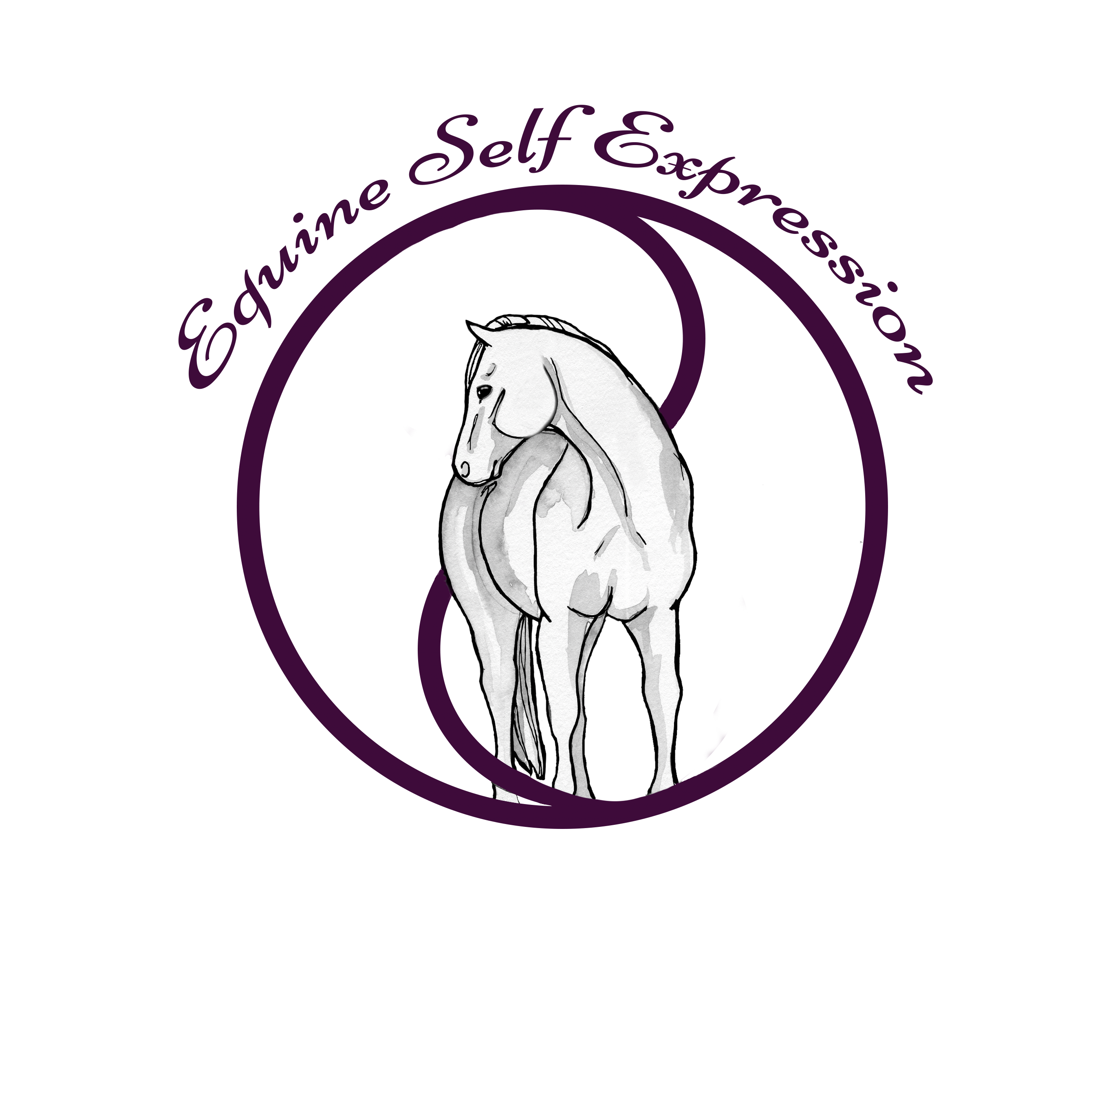
Equine Self Expression’s Healing, Growth and Learning Workshops~ Through the Eyes of Equus
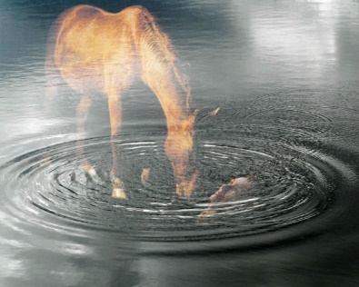

ESE Foundation Self Discovery Series

Calling on the Inner Self – Who Am I?

Presented by Deborah Bowerman Davies & Equine Self Expression

The Foundation Workshop is the first in the series of the Healing, Growth and Learning workshops which introduces the idea of the self-exploration concept through the journey of Equus. It is this experience that assists us in recognizing our own areas of misaligning beliefs and lack of self-trust.

This Foundation Workshop is a pre requisite to all others in the Self Discovery Series

WHEN: May 19 – 21, 2020~ 9:00am – 5:30pm
WHERE: 221, Mansfield Drive, Spartanburg, SC 29307
COST: $650.00 per person

Horses provided, maximum participants -8
This is a non riding workshop and is not open to auditors

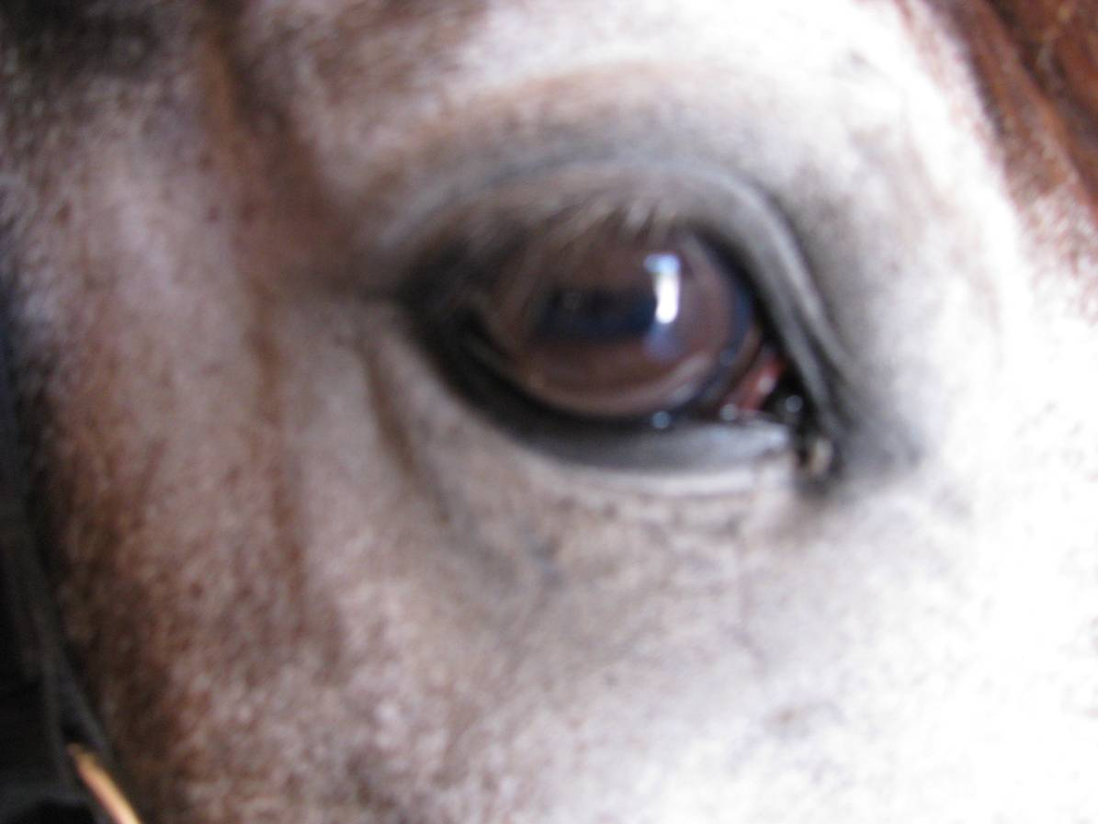
Equine Self Expression offers a series of workshops related to individual and group Learning, Growth and Healing. Our workshops build upon each other and provide participants with a solid internal foundation for their journey of self-exploration. As the workshops progress individuals find themselves clearing away more and more self imposed obstacles based on fear, belief systems, indoctrination and unfulfilled dreams.
Many individuals chose to participate in the entire series of workshops in the order suggested over the course of several years, treating themselves to an internal vacation each year!! Other people begin with the mandatory first workshop but there after pick and chose depending upon their particular needs.

For more information on registration, this workshop or the entire series, please go to www.equineselfexpression.com
Or contact clinic host
Martha Foster at 864-266-3522 or mitfost@gmail.com

